Using the create-react-app command

If you do not want to install react by using webpack and babel, then you can choose create-react-app to install react. The 'create-react-app' is a tool maintained by Facebook itself. This is suitable for beginners without manually having to deal with transpiling tools like webpack and babel. In this section, I will be showing you how to install React using CRA tool.

The Create React App is maintained by **Facebook** and can works on any **platform**, for example, macOS, Windows, Linux, etc. To create a React Project using create-react-app, you need to have installed the following things in your system.

1. Node version >= 8.10
2. NPM version >= 5.6

**Install NodeJS and NPM**

**Install React**

You can install React using npm package manager by using the below command. There is no need to worry about the complexity of React installation. The create-react-app npm package will take care of it.

1. >npm install -g create-react-app

**Create a new React project**

After the installation of React, you can create a new react project using create-react-app command. Here, I choose **jtp-reactapp** name for my project.

1. >create-react-app jtp-reactapp

NOTE: You can combine the above two steps in a single command using npx. The npx is a package runner tool that comes with npm 5.2 and above version.

1. >npx create-react-app jtp-reactapp

The above command will install the react and create a new project with the name jtp-reactapp. This app contains the following sub-folders and files by default which can be shown in the below image.

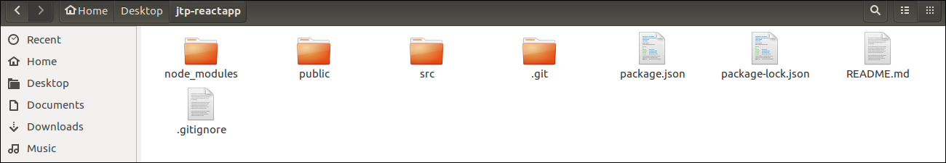

Now, to get started, open the **src** folder and make changes in your desired file. By default, the src folder contain the following files shown in below image.

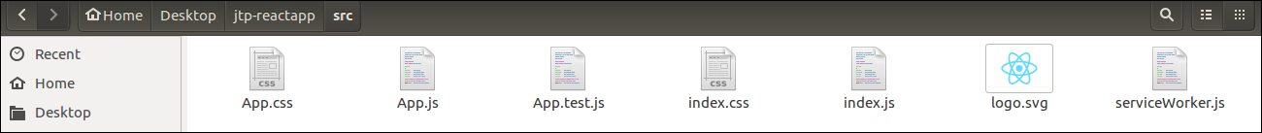

For example, I will open **App.js** and make changes in its code which are shown below.

***App.js***

1. **import** React from 'react';
2. **import** logo from './logo.svg';
3. **import** './App.css';
5. function App() {
6. **return** (
7. <div className="App">
8. <header className="App-header">
9. <img src={logo} className="App-logo" alt="logo" />
10. <p>
11. Welcome To JavaTpoint.
13. <p>To get started, edit src/App.js and save to reload.</p>
14. </p>
15. <a
16. className="App-link"
17. href="https://reactjs.org"
18. target="_blank"
19. rel="noopener noreferrer"
20. >
21. Learn React
22. </a>
23. </header>
24. </div>
25. );
26. }
28. export **default** App;

**NOTE:** You can also choose your own favorite code editor for editing your project. But in my case, I choose Eclipse. Using the below link, you can download Eclipse for Ubuntu and install.

**Running the Server**

After completing the installation process, you can start the server by running the following command.

1. >cd jtp-reactapp
2. >npm start

It will show the port number which we need to open in the browser. After we open it, you will see the following output.

